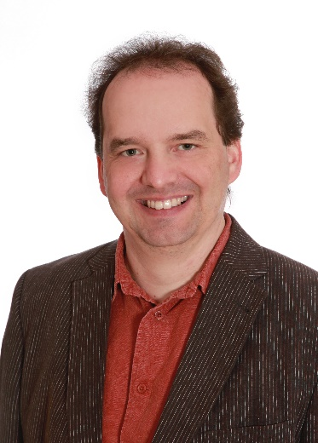
CV of Dr. Martin Knipper
I studied physics in Oldenburg, Germany and Denver, Colorado, USA and finished with a diploma degree in 2002 under the supervision of Prof. Dr. Juergen Parisi. After that I did my Phd also in physics at the university of Hasselt, Belgium and the University of Oldenburg under the supervision of Prof. Dr. Vladimir Dyankonov and finished in 2006. The topic of my Phd thesis is “Optical and electrical spectroscopy on alternative absorber materials for organic solar cells”. Since 2006 I work as a postdoc in the Energy- and Semiconductor research group of Prof. Dr. Juergen Parisi at the University of Oldenburg. From 2006 until 2011 my main topic was the characterization of chalcogenide thin film solar cells. Since 2011 my focus is on energy storage materials and fuels cells. Since 2017 I am the group leader of the “Energy storage technologies”- group. My main research interests are materials science (Energy Storage, Photovoltaic, Fuel Cells, Renewable Energies). Since 2009 one important method is the X-Ray diffraction to characterize different materials.

